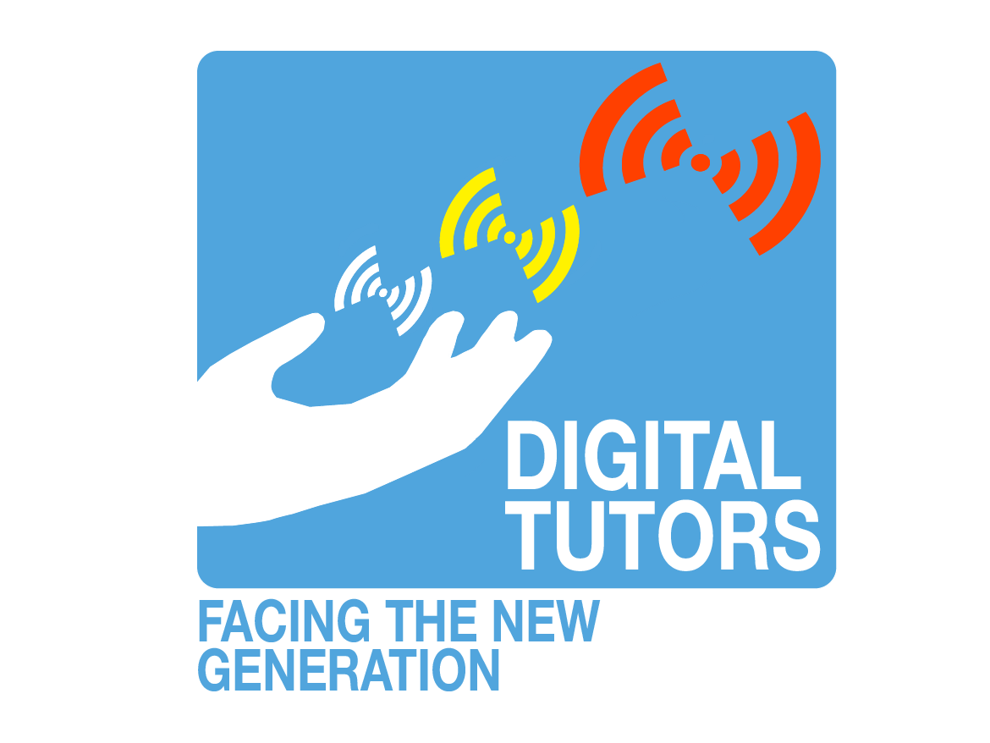
DIGITAL TUTORS
LHF and ROC FP SURVEY & INTERVIEW RESULTS
The objectives of the project Digital Tutors is to define the role of a Digital Tutor, to improve the teaching-learning process of online and blended training courses, to upskill online teachers and trainers as “digital tutor” and to create a resource repository to support digital tutors in their daily work.
The project’s objectives are divided into 4 Intellectual Outputs (IOs). The first IO is “DIGITAL TUTOR role definition and competences map”. One of the steps contributing to finalizing this IO is to conduct interviews with some experts and VET Centres at the partner’s locations. Partners also sent out the survey to the VET teachers and employees at their organization to gather information about the desired competences a Digital Tutor should have.

Table of Contents
Conclusion of the survey 3
The survey 3
The results 4
1. Participants’ schools 4
2. The definition ‘digital tutor’ 4
3. Ways of communication between teachers and students 4
4. How to take into account the different ways of support and guidance a student needs in an online teaching environment? 5
5. How to guide collaboration online / digitally? 6
6. Monitoring student behaviors in an online classroom 6
What do teachers need to monitor the student behaviors better? 7
7. How to keep track of the student progress in the digital environment 7
What do teachers need to be able to monitor the students progress? 8
8. How to determine if an intervention is needed and which tools can help? 8
Suggested tools or ways to help knowing when the online interventions are needed 9
9. Suggestions developing the teacher’s digital supervision of their students 9
10. Do you want to stay updates about the project? 9
In-depth interview with Mrs. Rim Bleeker, teacher at Friesland College (Vocational Education) 10

Conclusion of the survey
We can conclude that there is a gap between teachers knowledge: some have more knowledge with online teaching than others and feel more self-assured about it. Peer to peer learning has been mentioned as a way to overcome this gap. Also, knowledge of existing (free) online tools to make online teaching more engaging would be welcome and way to improve engagement with the students.
A second conclusion, is that a part of the teachers handle things online the same as ‘’face-to-face”. The question here is, whether the result of this way of teaching online reflects on the results of the students. Other way to put it: does this way of teaching have a positive or negative effect on the students’ results?
It would be interesting to ask the students. After all, they are the reason we try to ameliorate digital tutoring.

The survey
The questionnaire contains 11 questions in total, including 1 question about the respondent’s name (which is optional) and 2 questions about whether he/she wants to be updated about the project. The questions are shown in the figure below:

Figure 1: Survey questions
Each question was structured to get as much details as possible from the participants without violating their privacy. As a result, the participants would feel more secure and motivated to share their opinion.
In order to analyse the survey, the responses in each question were gathered then analysed by categories. This means that the answers in each question were summarized and classified in similar categories.. The analysis and conclusions can be viewed without requiring extra knowledge or access and thus are accessible for everyone.

The results

Participants’ schools
The survey received 11 respondents from 2 schools in the Netherlands: MBO Utrecht and ROC Friese Poort.
After they took the questionnaire the participants were asked to give their opinion on the definition of a digital tutor and the required skills one should have.

The definition ‘digital tutor’
Figure 2 shows that 46% of the participants understood the definition, but still had some questions remaining. These questions, or comments are “Why is the definition necessary? ‘’What is the difference between a digital tutor and a teacher?’’ Or ‘’I have never heard of this before”.
It is also interesting to point out that 20% of the attendants like the project’s logo a lot, 13% prefer to have the definition in Dutch for a better understanding and the rest of the opinions are divided into 3 points: Agree with the definition, Doubting it (this response said the definition is overly complicated) and the last one, ‘Has another thought about it’ (this attendee thought that the managing and securing digital assets is more a task for specialists, not for a teacher/ tutor).

Figure 2: Thoughts on the definition of digital tutor

Ways of communication between teachers and students
In terms of online communication methods, most of the teachers have been using Microsoft Office and Mails. Some teachers also use Whatsapp, FP-C@Campus, phone calls or planned appointment to keep in touch with the students.

Figure 3: Ways of communication between teachers and students

How to take into account the different ways of support and guidance a student needs in an online teaching environment?
In terms of how to determine whether students need extra support or attention in the online learning environment, different answers were given:

Figure 4: How to take into account the supports/ guidance student needs in the online environment?
As can be seen from figure 3, 64% of the teachers said a good or extra preparation is helpful. Preparation here means preparing different teaching methods, assignments and activities (for both in class and in Teams) so there is always something suitable for every student. Moreover, 9% of the participants reckoned that talking with the students will determine if they are in need of (extra) support or guidance.
Besides that, 18% of the participants stated that they pay attention to this aspect as much as in the regular (offline) teaching ways, while 9% pays little extra attention to it.
The next aspect is about guiding a digital collaboration, how have they done and whether there are any differences with the physical collaboration. The findings are shown in figure 5 and 6.

How to guide collaboration online / digitally?
Looking at figure 5, we know that the most common way to guide a digital collaboration is using the Break Out Rooms (BOR) in Teams for different group works. The least common way to do this is offering help when necessary to the students during the collaboration.

Figure 5: How to guide collaboration online/digitally
In table 1, the differences between guiding collaboration online versus offline are listed. It is easily to point out that there are several differences that teachers have to face when guiding a digital collaboration.
Simulating interactions
Difficult to motivate students
Switching to BOR takes time
Online connection
Difficult to focus listening
Students can easily ask you a question
Table 1: Differences in guiding a digital collaboration compared to the physical one

Monitoring student behaviors in an online classroom
In terms monitoring the students behavior in the digital learning environment, several answers were given. Extra tools that would be helpful in this case, are shown in table 3.
Answers given | Number of respondents gave the similar answer
Raise hands & turn on the cameras | 2
Pay attention to students | 2
Give students homework in BOR | 2
Asking questions at random moments | 2
Work together with them in the classroom | 1
Use Teams and Xedule to keep trck | 1
Give feedbacks | 1
Observation, work in smaller groups | 1
Table 2: How to keep track of the student behaviors in the digital environment
From table 2, the 4 most common ways to monitor are: asking the students questions at random moments during the lesson, give students homework to do in the BOR so they have to finish and submit it in the end of the activity, pay attention to the students (like in regular live education) and ask them to turn on their cameras and raise hands when they want to say something.

What do teachers need to monitor the student behaviors better?
The tools that the participants thought that would help them in monitoring their student behaviors are:
Clear rules about what teachers may and may not ask the students
More freedom to teach the classes the way they want
Table 3: What teachers need to keep track of the student behaviors

It seems like because of the online learning, some schools have set the rules for teachers when teaching digitally, and some of the rules are either vague or too stiff for both the teachers and students.

How to keep track of the student progress in the digital environment
The next aspect is about monitoring the student progress in the digital learning environment. Again, we asked whether the teachers needed additional tools or knowledge for this.

Figure 6: How to keep track of the students progress in the digital environment
It is clear that almost 50% of the survey’s teachers use the digital school apps like Eduarte, FP-C@Campus, Xedule, to keep track of their students progress. Besides that, the manual keeping track of student’s results (via their assignments and tests) and having a weekly, personal talks with them were used quite often. The least used way is to ask them questions and work in smaller groups for easier control.

What do teachers need to be able to monitor the students progress?
To answer this question, the participants have given answers that can be summarized below:
A better system

Same as face-to-face

A webcam in the room students are sitting

Table 4: what teachers need to keep track of their students progress

During the analysis of this aspect, the answer “Same as face-to-face” were repeated several times (even in different questions). It can be understood as “the same as in regular, offline teaching”.

How to determine if an intervention is needed and which tools can help?

Figure 7: How to know when an intervention is needed
From figure 7, the most used way to know when an intervention is needed is when the student’s results are not good/ not improved and when a teacher rarely sees the student(s). Furthermore, other ways can be checking the student’s assignment to know about their progress to pay closer attention to the ones that are vulnerable or via working with students in the class (online or offline).
However, some teachers did find this aspect difficult to recognize in the digital environment. But, the answers said that they are willing to learn how from other teachers. On the contrary, there were teachers who find it the same like in the normal, regular time.

Suggested tools or ways to help knowing when the online interventions are needed
The findings about which tools or ways that are useful for spotting the need for an online intervention are shown in table 5.
Lots of observation to the students
Contact the SLB-person
1-on-1 with students
Same as face-to-face
Table 5: What teachers need to know when an intervention is needed

Suggestions developing the teacher’s digital supervision of their students
Knowledge of good tools
Courses and trainings for those tools
Tips, advices and experiences sharing from other teachers
Teaching normally again
Nothing
Not sure about this
More help or guidance with using Teams and FP-C@Campus
Table 6: What teachers need to improve the online supervision for their students

We can conclude that teachers want to have some tools that help them in supervising their students digitally better, but they do not know what kind of tools needed for this yet.

Do you want to stay updates about the project?
The answers in question 10 and 11 are combined since they are linked together. In the end of the survey, we asked the participants whether they want to be updated about the project. Most of the answers were sadly no. The ones that said yes but did not leave their emails for us to contact back.

In-depth interview with Mrs. Rim Bleeker, teacher at Friesland College (Vocational Education)
As mentioned in the beginning, besides to the survey, each partner had to conduct some interviews with and an expert the field of teaching. For FC and LHF, an interview was made with Mrs. Rim Bleeker, a teacher with long experiences at Friesland College. The interview answers are summarized and shown below.
According to Mrs. Rim, she has lots of experiences with organizing and implementing online teaching, as she had to make and give online lessons to students since Corona started. She does this by combining the synchronous and asynchronous education. The age range of her students are 16-25 years old. She uses a notebook to plan her online teaching schedule, which is the same way like before Covid. She meets her students 1 time per week and here is how she implements the learning activities in the synchronous education:
“Usually, I begin with giving some inspiration for the lesson to the students live. After that, they get an assignment and go to work on it in a meeting (BOR). Then they come back, discuss for 10 minutes, and then they go out again. And so on.”
Rim uses Microsoft Teams for the live sessions and video conferences. The purpose of doing these continuous short actions which do not let the students present for more than 10 minutes will not give students the opportunity to drop out. She also added she has used this method with the target group (Vocational students) and in small groups (max 8-12 students per group).
Sometimes, she uses the asynchronous education to her students, which means that the lessons will be published online so students can read, study and finish it in their own time.
Since both Rim and the students have to work online most of the time, the necessary computer literacy skills for them are: Knowing how to work with Teams properly, mastering presentation software, making sure students follow the rules set by teachers. A tip from Rim for teachers in order to keep students focus on the communication ( learning - feedback - engaging) during online sessions is to have rules that are agreed by all students, such as raising hand when they want to speak and do not close their camera as well as mute their microphone.
In terms of difficulties when organizing and implementing online teaching, Rim said:
- Poor internet connection that affects the digital communication for both ways;
- Asking for feedback in the group doesn't work, you have to address someone personally’
In terms of additional trainings for teachers to acquire the digital competences, Rim thought that the creative and technical tools might be worth training on.
Everything goes both ways, if there are difficulties teachers are facing with online teaching, the students also experience the same with online learning. According to Rim, the biggest difficulty for them is motivation. Students get demotivated easily with online learning due to several factors, but they all lead to complains, being tired and not wanting to continue the study.
A worthy point to take from this interview is that while some teachers have a lot of experience teaching online, they are still not fully equipped with the cybersecurity and data protection knowledge.
She receives support for ICT use from the school's IT maintenance specialist team. She told us that their quality was good, and her school was pretty quick on updating the availability of the hardware.
In order to attract more teachers to learn and use technology in teaching, Rim thought teachers should have more time for the digital content creation. In her opinion, the lack of time in this area is the barrier for them. Rim agreed with us on some digital learning benefits that teachers will have from using more technology in their teaching, which are:
- Facilities collaboration
- Time-saving
- Supports independent learning
- Accessibility widen
- Expanding the learning opportunities
But, she also showed to us that the skill-related to the use of ICT should not be one of a tutor’s pedagogical competencies. To illustrate for her point, Rim said that she still has little confidence in using ICT in-depth despite the fact that she is provided lots of technical equipment (personal computer, interactive whiteboards, video conferencing system, LMS, audio equipment, digital photo & video cameras, mobile phones, etc) from the school.
For conclusion, it can be said that teachers have a fair knowledge in using the technical equipment in teaching online, however they do not have a proper understanding in some ICT-related fields e.g. data protection and could be trained to use (creative) tools more in order to make teaching more engaging.

